Global systems

Instructions to students  • You have 50 minutes to complete the test.  • Please answer all questions in the spaces provided.  • There is to be no talking during the test. | Marks  Section I: Multiple-choice questions: 10 marks  Section II: Short-answer questions: 33 marks  Section III: Extended-response questions: 7 marks  Total: 50 marks

Name: ________________________________________________________  Class: _________________________________________________________ | Score: /50  Grade: %
Comments:

Section I: Multiple-choice questions
For each question, circle the correct answer.
1 All of Earth’s water makes up the: |  | 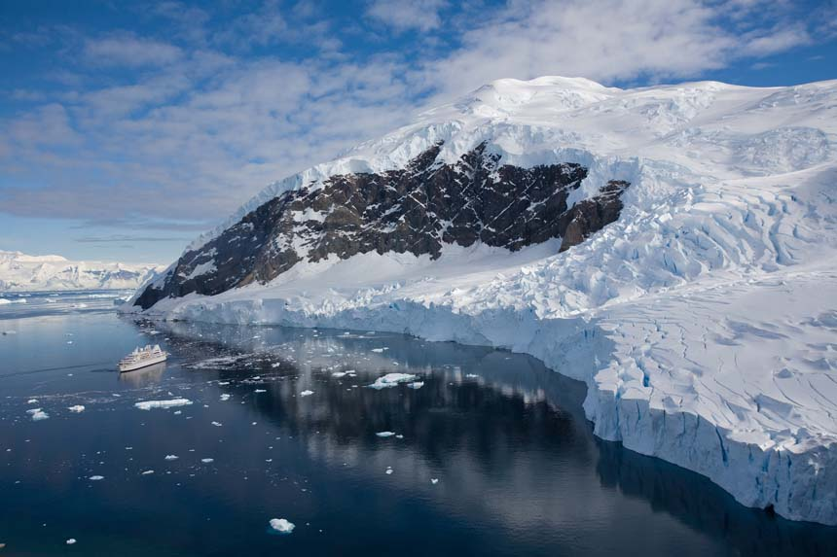
A | hydrosphere.
B | biosphere.
C | lithosphere.
D | atmosphere.
2 The most important gas for the survival of all animals is:
A | nitrogen.
B | carbon dioxide.
C | oxygen.
D | ozone.
3 Which sphere of the atmosphere is the thickest?
A | Mesosphere
B | Troposphere
C | Ionosphere
D | Stratosphere
4 Which of Earth’s sphere is the outermost layer, which merges with space?
A | The lithosphere
B | The mesosphere
C | The stratosphere
D | The exosphere

5 Bacteria, found in the root nodules of legumes, are essential in the cycling of: |  |  | 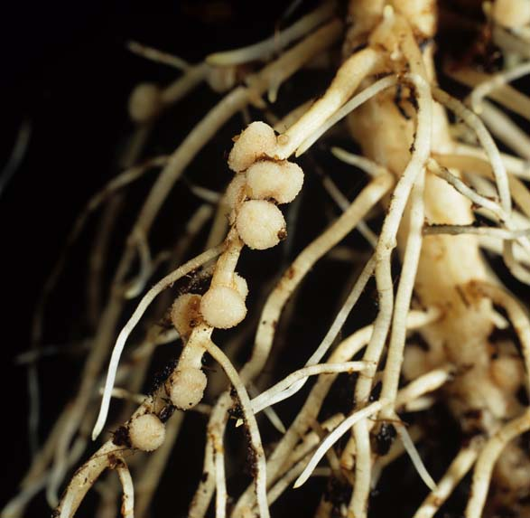
A | water.
B | nitrogen.
C | oxygen.
D | phosphorus.
6 Climate change is affecting people’s health. Which of the following statements is incorrect?
A | Infection zones for diseases that thrive in warm, moist conditions are increasing.
B | Urban sprawl is impeding the growth of hospitals and health facilities.
C | Higher temperatures are increasing heat-related fatalities.
D | Stagnant weather conditions can trap warm air and smog, leading to respiratory problems.
7 Which of the following is not a carbon sink?
A | Rocks and other carbonates
B | Organic matter in the soil
C | Atmosphere
D | Oceans
8 Which of the following devices is used to measure wind? |  | 
A | Anemometer
B | Thermometer
C | Barometer
D | Colorimeter

9 Wind is caused by differences in air pressure, mainly as a result of:
A | Earth’s rotation.
B | the gravitational pull of the Moon.
C | unequal heating of Earth’s surface.
D | Earth’s magnetic field.
10 The most damaging effect of the permafrost melting would be: |  | 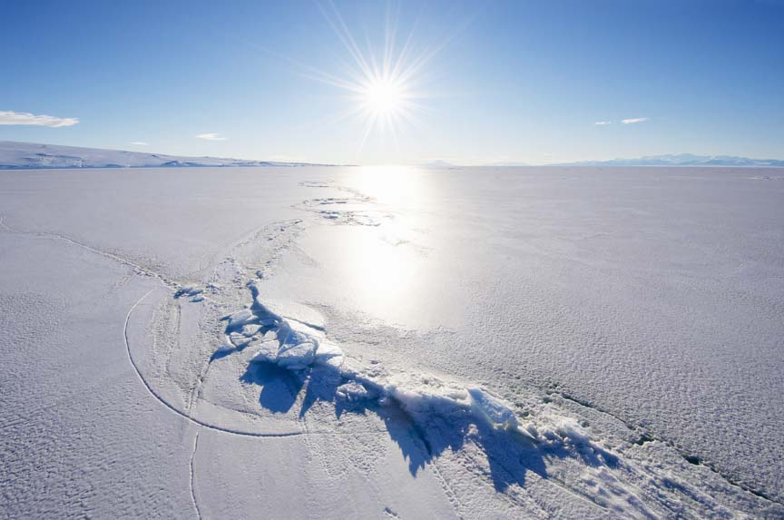
A | having nowhere to ski anymore.
B | sea levels rising due to the extra water.
C | massive changes to the world’s tides.
D | the release of large amounts of carbon into the atmosphere.
Section I total marks:
/10 marks

Section II: Short-answer questions
11 In the atmosphere, oxygen is formed through UV light converting water to oxygen and hydrogen. Name this process, labelled X on the diagram below, and write a chemical equation for this reaction.
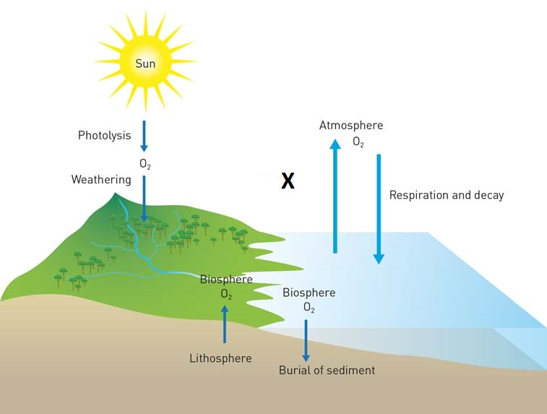
X:
Chemical equation:
/3 marks

12 How do photosynthesis and respiration contribute to the oxygen cycle?
 |  | /2 marks
13 What is the difference between climate and weather?
 |  | /2 marks
14 Name the Earth’s four major spheres.
 |  | /4 marks
15 Explain why regions near the equator are warmer than regions near the poles.
 |  | /2 marks
16 Explain how a cyclone forms.
 |  | /2 marks
17 Phosphorus is no longer included in detergents to reduce eutrophication.  Explain how excess phosphorus from detergents contributed to increased eutrophication in waterways. | 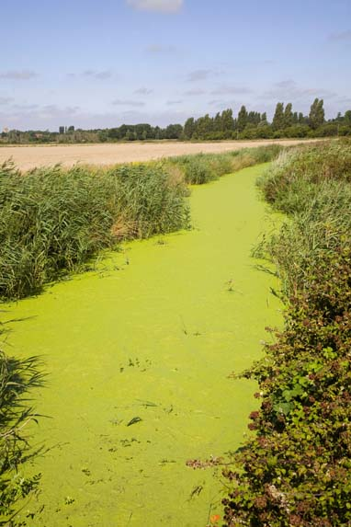  Eutrophication in an irrigation channel
 |  | /3 marks

18 Give two ways in which humans have contributed to the enhanced greenhouse effect.
/2 marks
19 Identify the major process (A–D) that continually cycle water through the hydrosphere, atmosphere and biosphere.
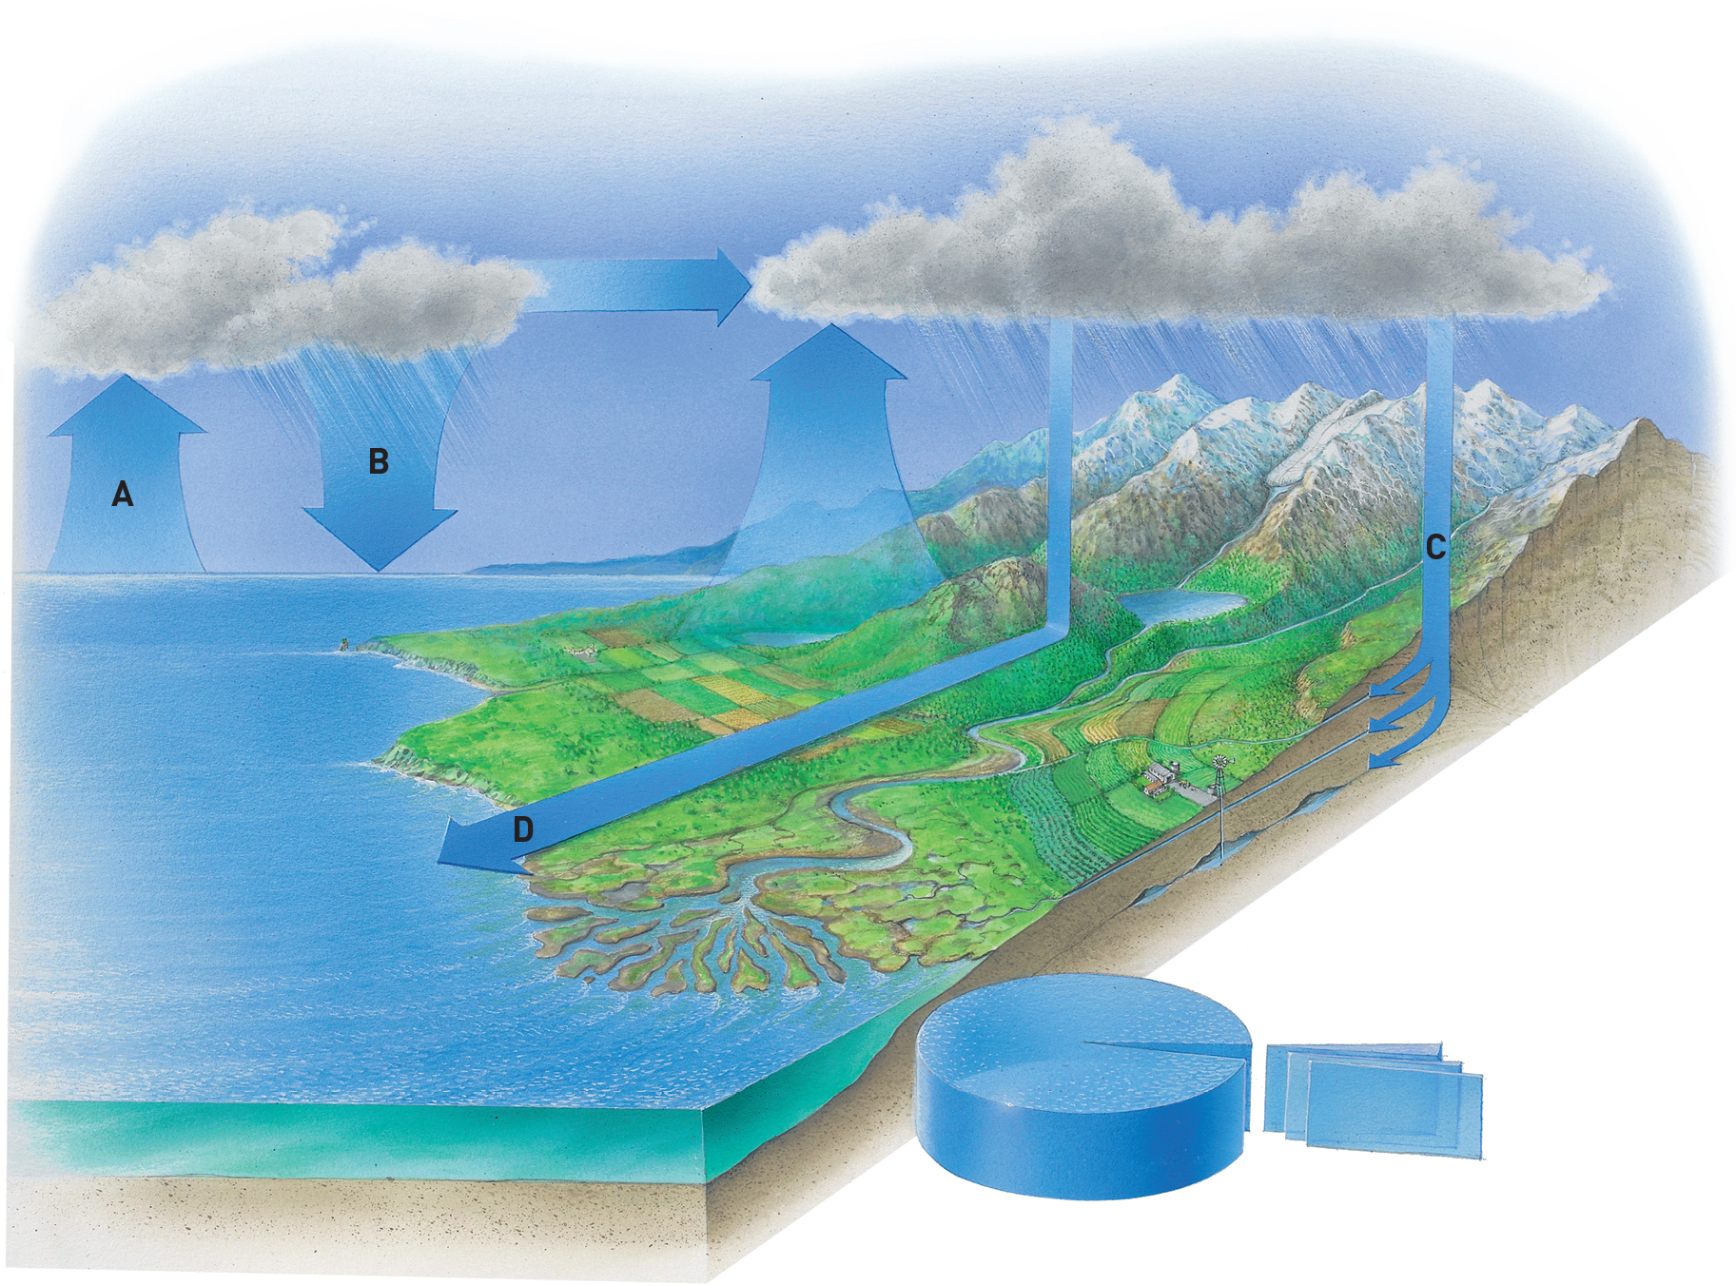
/4 marks
20 What is a carbon sink? Why are these so important?
/2 marks
21 Explain the role of bacteria in the nitrogen cycle.
/2 marks
22 Distinguish between the hydrosphere and the cryosphere.
/2 marks

23 Give three negative effects of melting sea ice.
/3 marks
Section II total marks:
/33 marks

Section III: Extended-response questions
18 Using examples, describe how two different observations or measurements have been made by humans to provide evidence of enhanced global warming.
/4 marks

20 There are many practices now being carried out to reduce global warming. Identify and describe ONE practice aimed at reducing global warming. Explain how your selected practice reduces global warming.
/3 marks
Section III total marks:
/7 marks

